USER REQUIREMENTS

The Bidder should provide the following in the specified order in Section 4 of the proposal/bid document.

Provide detail information of the proposed solution as per document enclosed. Please note that marking should be carried out in the following manner; The Remarks column should be used to explain or provide detail information.

DESCRIPTION | REMARKS
Rating - 5 | If the User requirement is met 100% as defined in the RFP without any work around method.
Rating - 4 | If the User requirement is met 75% as defined in the RFP without any work around method. Define the number of hours required for the modification and cost in US$ in the Remarks column, in order to provide 100% functionality as defined.
Rating - 3 | If the User requirement is met 50% as defined in the RFP without any work around method. Define the number of hours required for the modification and cost in US$ in the Remarks column, in order to provide 100% functionality as defined.
Rating - 2 | If the User requirement is met 25% as defined in the RFP without any work around method. Define the number of hours required for the modification and cost in US$ in the Remarks column, in order to provide 100% functionality as defined.
Rating - 1 | If the User requirement is met as a Work around method defined in the RFP. Define the number of hours required for the modification and cost in US$ in the Remarks column, in order to provide 100% functionality as defined.
Rating - 0 | If the User requirement is not met as a defined in the RFP and modifications are required. Define the number of hours required for the modification and costs in US$ in the Remarks column.

The NBL rating is as follows:
1 = critical; 2 = essential; 3 = nice to have

CONSUMER CREDIT OPS (CPU) - OVERDRAFT FACILITIES
Ref | Requirements | NBL Priority | Bidder Rating | Bidder’s Remarks
 | GENERAL REQUIREMENTS
 | Fixing of Overdraft limits would enable to overdraw the Account up to limit specified in the system. The debit balance in the current account should accrue interest based on the daily value balance at the rate specified and debited to the account at month end. In the event the debit balance exceeds the limit specified system should compute interest on the excess at a penal rate specified at account or product level. Any Transaction that would create excess in the account Except for Interest, Charges and taxes should trigger an over ride which would require authorization. | 1 | 5 | Supported by T24
 | Should be able to input / identify the business line /Account Officer at Facility account level | 1 | 5 | Supported by T24
 | Further categorize / Flag facility accounts by way of product codes i.e.  At Cash backed lending rate / Deposit rate based ect. Ect. | 1 | 5 | T24 provides product codes for product categorization.
 | Should be able to differentiate between Temporary Overdraft Facilities and Permanent facilities. Temporary overdrafts with security & without security | 1 | 5 | Handled by the Limit module.
 | Should be able to fix multiple limits for a particular account | 1 | 5 | Supported by T24
 | Should be able to input concessionary penalty interest rates at account level |  | 5 | T24 has facility to define balance calculation for penalty such as principal overdue, interest overdue, charge overdue
 | Should be able to link collateral to the facility limit | 1 | 5 | The Collateral record is kept in the Collateral module in T24 and it can be linked with a Limit, a Facility, a loan or a customer.  T24 supports the following linkages in between Collateral and Limit:  - One Collateral linked to One Limit  - One Collateral linked to Multiple Limits  - Multiple Collaterals linked to One Limits  - Multiple Collateral linked to Multiple Limits  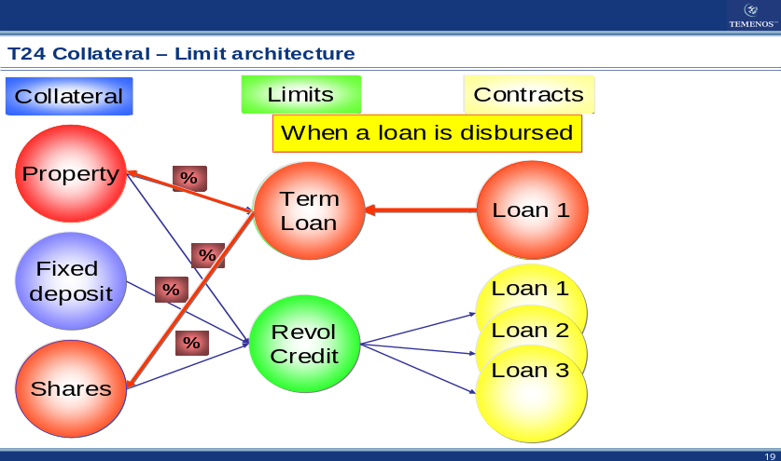  Figure 1. T24 Collateral – limit architecture  One or multiple Collaterals can also be directly linked to one or multiple loans/customers.
 | In the event the facility being granted against a Deposit account the account pledged as collateral should be linked to the facility account and a lien created for the amount or percentage specified. | 1 | 5 | Deposit is supported as internal collateral in T24.  Allow automatic rating of collaterals using external news feeds, especially for collateral stocks and bonds.  Support management of collateral status (including closed, in-progress, and in-transit collateral).  Values are awarded to collaterals in various forms such as nominal, accepted, third party and specific values for general ledger and regulatory reporting. Such values may be either entered as collateral specifically or fed from another T24 module or even from external feeds via interfaces.
 | Should be able to link more than one deposit account / Collateral to a single facility. | 1 | 5 | Supported by T24
 | Such lien marked should be reflected in the deposit account | 1 | 5 | Supported by T24
 | Deposits under lien should be renewed with Lien at maturity and details of the renewed deposit be shown as collateral for the facility | 1 | 5 | The Collateral portfolio can be restructured at any time in T24.  Amendments and restructuring of Limits / Loan contracts are also supported and all the history records are stored in T24 for online enquiry.  Even for the special restructuring that a new limit/loan has to be generated to replace the old one, the old contract ID can also be kept as reference in the new contract
 | In the event of a Foreign Currency Deposit is pledged, Collateral valuation should be done by the system and any facility where there is in sufficient collateral be identified and rectified  e.g. If the customer collateral value decreases, facility limit to be adjusted accordingly. | 1 | 5 | T24 has facility to have the online limit is fixed or variable. The underlying collateral should be recorded in the T24 Collateral Module.  The system recognizes two types of secured limit. A variable limit is one for which the system automatically allocates the value of any underlying collateral against the limit and calculates the ONLINE LIMIT amount on the basis of this secured amount. A fixed limit is similar, except that the value of the ONLINE LIMIT amount is never adjusted. In other words, the secured amount belonging to a fixed limit is calculated for information purposes but not for the system's limit checking.
 | Should be able to Share Collateral with other facilities (provided the total amounts pledged does not exceed the deposit amount) | 1 | 5 | One or multiple Collaterals can also be directly linked to one or multiple loans/customers.  E.g. Define the coverage relationships to multiple loans: Dell Computer provides collaterals to cover its three loans and the loan specific coverage ratio (Allocation %) is defined for each loan.  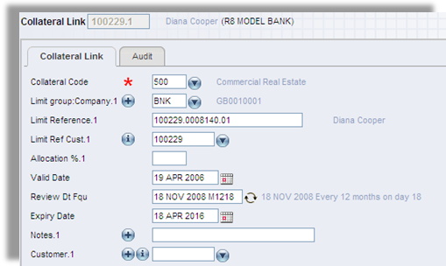  Figure 2. Collateral Link
 | Limit Expiry Date – This should be the facility expiry date, | 1 | 5 | Supported by T24
 | Credit Facility Free Text – This Screen allows you to input any further details that may be required concerning the facility. The facility free text should be shown on all facility reports. | 1 | 5 | T24 has facility for the bank to enter information in credit facility. The field for information is multi value fields that can be expanded as needed. All T24 applications and transactions can be retrieved easily by using enquiry designer, where the user can define what kind of information are needed to be printed in the reports or to be viewed  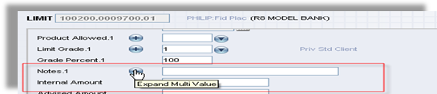  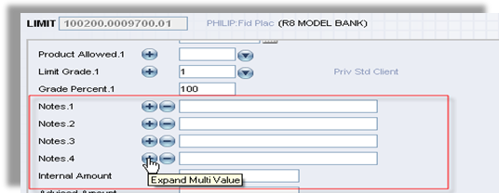  Figure 3. Credit Facility Free text multi value
 | Should accommodate multiple interest structures | 2 | 5 | T24 has functionality to setup multiple interest rates that can be differentiated by term, amount, effective date, currency, product, etc. Grace period is also a standard functionality in T24 and can be defined when opening new loan
 | Should be able to link more than one overdraft facility to a particular account | 2 | 5 | Supported by T24
 | Should be able to effect interest rate changes scheme wise, account wise, tier wise |  | 5 | Supported by T24
 | Collect charges i.e. processing fee, renewal fee ect. |  | 5 | T24 also allows the bank to collect charges for ad-hoc statement printing
 | Facility to back date interest Conditions |  | 5 | Backdating is allowed within integrity and internal control compliance features.
 | Provision to have interest debited to another account other that the facility account belonging to the same customer. |  | 5 | Supported. In addition, T24 generates a warning message to highlight the different ownership of the account.
 | Enhance, reduce, cancel existing facility Lines |  | 5 | Supported by T24.
 | Liens to be released upon cancellations |  | 5 | Handled by T24 Collateral module. Manual cancellation is provided.
 | Flagging of NPA and provisioning according to CBSL guidelines, provisioning and suspension of interest |  | 4 or 5 | Handled by T24 Past Due module. Need to study CBSL guidelines to determine whether or not local enhancement is required.
 | Account level validations – i.e. Facility limits cannot be fixed for accounts where status is dormant | 1 | 5 | Supported by T24
 | Ability to view limit / collateral history | 1 | 5 | Supported by T24
 | Should facilitate rate revisions automatically when the deposits pledged are renewed ( to be identified and done only for limits were the lending rate is linked to the deposit rate) |  | 5 | Supported.
 | To identity the facilities with special rates & the tenor of the facility where special rates are approved. | 1 | 5 | Supported.
 | Provision provided in the system for change of security to another (e.g. fixed  Deposits, savings a/c, treasury bills, treasury bonds, Treasury bill repo, treasury Bonds and corporate paper) should be updated | 1 | 5 | Supported by T24
 | Need a free text area to input remarks/comments in approval level |  | 4 | This functionality would require minor customization.
 | Deposit rate & OD Rate Combination | 1 | 5 | This is Supported by T24
 | Reports / MIS Requirements | 1 | 4 | All T24 applications and transactions can be retrieved easily by using enquiry designer, where the user can define what kind of information are needed to be printed in the reports or to be viewed
 | Audit activity trail | 1 | 5 | Supported by T24
 | Reviews falling due/OD Review list | 1 | 4 | All T24 applications and transactions can be retrieved easily by using enquiry designer, where the user can define what kind of information are needed to be printed in the reports or to be viewed
 | Collateral due for renewal | 1 | 5 | This is Supported by T24  Support flexible restructuring of collateral portfolio and limit structure when customer dictates  The Collateral portfolio can be restructured at any time in T24
 | Overdue reviews | 1 | 4 | All T24 applications and transactions can be retrieved easily by using enquiry designer, where the user can define what kind of information are needed to be printed in the reports or to be viewed
 | Facility Disbursement advice to Customer | 2 | 5 | This is Supported by T24
 | Facility review letter, rate changes / Advice to customer | 1 | 5 | This is Supported by T24
 | Balance Confirmation Advice – as at a specific date | 1 | 5 | Handled by T24 Delivery module.
 | Conformation of Interest paid for a given period | 1 | 5 | Handled by T24 Delivery module.
 | Collateral short fall report | 1 | 4 | All T24 applications and transactions can be retrieved easily by using enquiry designer, where the user can define what kind of information are needed to be printed in the reports or to be viewed
 | Limit history Report by Customer | 1 | 4 | All T24 applications and transactions can be retrieved easily by using enquiry designer, where the user can define what kind of information are needed to be printed in the reports or to be viewed
 | To view all the given OD details with customer name, a/c no, limit  Amount, account officers name, interest rate, etc | 1 | 4 | All T24 applications and transactions can be retrieved easily by using enquiry designer, where the user can define what kind of information are needed to be printed in the reports or to be viewed
 | Facilities lien over foreign currency deposits | 1 | 5 | Handled by T24 Collateral module
 | Total given OD’s, (TOD/POD) | 2 | 5 | Supported by T24 similar standard report or enquiry.
 | Total OD Portfolio( TOD/POD) | 1 | 5 | Supported by T24 similar standard report or enquiry.

